# 

# 

# 

***Train Simulation***

Use Case Specification Document

**Case Id 10**

**Rollback Simulation History**

Version No. 1.0

Project Document Revision History

|  |  |  |  |
| --- | --- | --- | --- |
| **Version Number** | **Date** | **Revision Author** | **Description of Revision** |
| 1.0 | 3/13/19 | Orlando Murrell | Initial Version |

# 

Table of Contents

**1. Introduction** **4**

**2. Use Case Information** **4**

2.1 Actors 4

2.2 Use Case Interaction 4

**3. Trigger** **4**

**4. Pre-condition(s)** **5**

**5. Post-Condition(s)** **5**

**6. Use Case Swimlane Diagram** **6**

**7. Main/Basic Flow(s) of Events** **6**

7.1 Main Flow 6

**8. Alternative/Exception Flow of Events** **7**

8.1 Time out of bounds 7

**9. Assumptions/Business Rules including Non-Functional Requirements** **7**

# 

# **1. Introduction**

Users will be able to compare metrics and data from their current simulation with previous data points. A ~~side-by-side~~ comparison will be available to view metrics about trains, train stations, hubs, railways, and trains after providing a date in between the start and end dates for comparison. The previous data will be available without re-running the entire simulation.

# **2. Use Case Information**

## 2.1 Actors

|  |  |  |
| --- | --- | --- |
| Actor Name | Role | Description |
| User | Main | This is a human that starts and stops simulation. Select files that would be read and processed. Start simulation to create new day. Weather is decided by user. View files. Add hubs, stations, and tracks. Adjust hubs and stations associated with tracks. |
| Simulation System | Secondary | Run files. Display activity. Show visual representation of simulation graph. |
| UI | Secondary | Show visual representation of simulation graph. |

## 2.2 Use Case Interaction

A list of predecessors use cases are as follows:

Use Case 1 - Setup Initial State: Rollback simulation history will only be available after the initial state has been set.

Use Case 6 - Run Simulation: Rollback simulation history will only be available after the simulation has run to the point that it’s possible to compare two states

# **3. Trigger**

Rollback Simulation History is triggered when the user requests to view a day  ~~compare two days~~ that the simulation covered.

# **4. Pre-condition(s)**

1. The simulation must have already been executed to at least 1 day in the future.

# **5. Post-Condition(s)**

1. Display two arbitrary states created from the simulation.
2. Display current state if at least one value is out of bounds.

# **6. Use Case Swimlane Diagram**

~~OLD~~

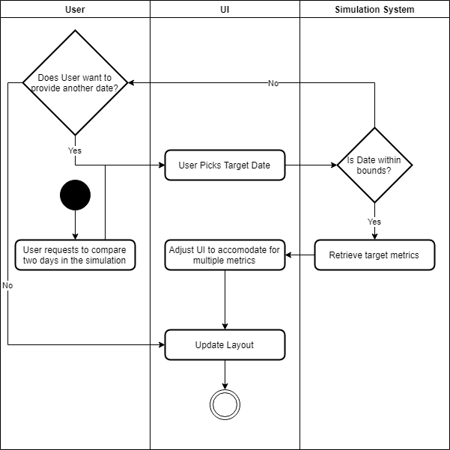

# 

NEW

# 

# **7. Main/Basic Flow(s) of Events**

## 7.1 Main Flow

The User makes a request to compare the current state of the simulation (either the end or an arbitrary point from pausing it) to a previous state. Via the UI, the user provides a point in time between the start of the simulation and the current point. The UI submits the information to the simulation system, and the simulation system provides the UI with the metrics collected from that point in time to the UI. The UI adjusts its layout to accommodate for the new information and updates its display to show the user a comparison between the current state and the requested state.

# **8. Alternative/Exception Flow of Events**

## 8.1 Time out of bounds

The User makes a request to compare the current state of the simulation (either the end or an arbitrary point from pausing it) to a previous state. Via the UI, the user provides a point in time between the start of the simulation and the current point. The point in time is not within the bounds of the simulation however because it is either after the current state or before the start of the simulation. The UI alerts the User that their input is incorrect, and allows them to supply a new point in time, or cancel the operation all together

# **9. Assumptions/Business Rules including Non-Functional Requirements**